CPT103 Coursework Report

# Must Read

Your report and database design must be your own work. You should not copy any code from others or let anyone develop this PMMS. Plagiarism and collusion lead to a zero mark for this coursework.

All tables must be in 3NF and the ER diagram should not contain any M: N relationships. Please strictly follow the structure of this template. Remember to double-check grammar and wording errors so that the report could be understood easily. Failing to do so will result in mark deductions. Any language other than English will be ignored when marking the report.

Your ID: 2034172

Name: Shuchen.Ji

Email Address: Shuchen.JI20@student.xjtlu.edu.cn

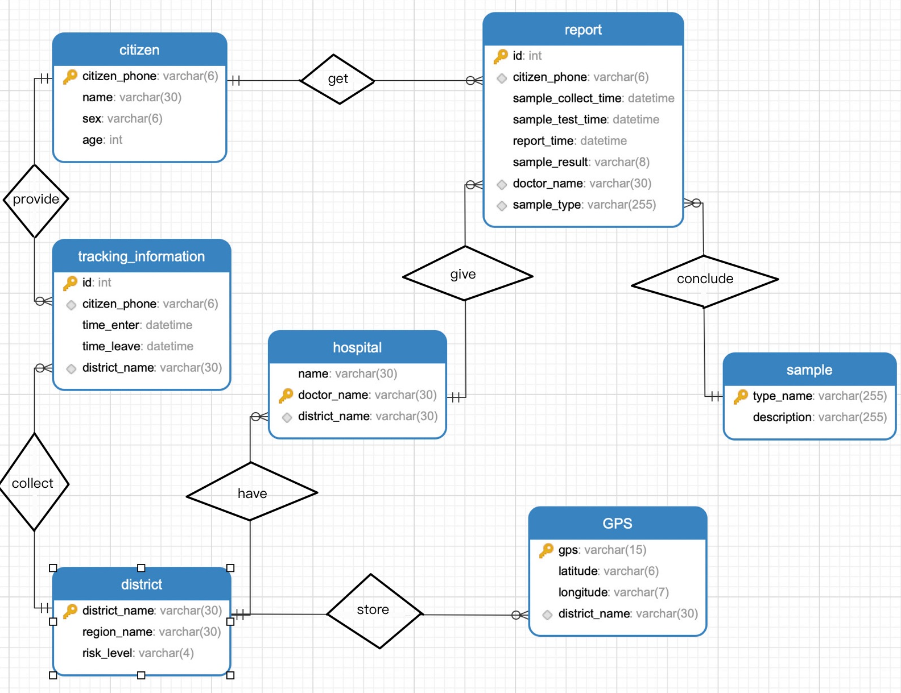

# Database Design Details

## Tables

In this section, you are required to explain all of the tables in your ER diagram. An example is given below. Please make sure you follow the template and everything is clearly explained.

Table name: citizen

Table design explanation:

The citizen table is used to store the information of all citizens in The Lukewarm Kingdom that have been investigated. The primary key is citizen_phone as it is unique for every citizen, and it can uniquely identifies each row in the table.

Attributes:

|  |  |  |
| --- | --- | --- |
| Column Definition | Domain | Explanation |
| name varchar(30) | All valid names are acceptable. For example, ‘Mark’. | Name of citizens. To save storage space, citizen’s name can be up to 30 characters long. |
| sex varchar(6) | Male or female | Sex of citizens, the data cannot be checked by the database directly. As a result, manual checking is required when entering data. To save storage space, citizen’s name can be up to 6 characters long. |
| age int | 0-100 | Age of citizens. |
| citizen_phone varchar(6) primary key | A combination of 6 digits. For example, ‘233636. | Phone numbers of citizens. Different person has different phone number. To save storage space, citizen’s phone number can be up to 6 characters long. |

Table name: report

Table design explanation:

The test_result table is used to store the information of virus test report for citizens. The primary key is id which is an auto_increment primary key and the purpose of setting id is to prevent the use of a compound primary key which may affect the setting of foreign key if the same person be tested for multiple times.

Attributes:

|  |  |  |
| --- | --- | --- |
| Column Definition | Domain | Explanation |
| id int primary key | Auto_increase from 1 | It is an order starting at 1, and it doesn't matter if the same person is tested multiple times. The purpose of setting id is to prevent the use of a compound primary key which may affect the setting of foreign key if the same person be tested for multiple times. |
| citizen_phone varchar(6) | A combination of 6 digits. For example, ‘233636’. | Phone numbers of citizens. Different person has different phone number. To save storage space, citizen’s phone number can be up to 6 characters long. |
| doctor_name varchar(30) | All valid names are acceptable. For example, ‘yanwei’. | Name of doctors. Suppose that different doctor has different name. To save storage space, doctor’s name can be up to 30 characters long. |
| sample_type varchar(255) | All kinds of the virus. | There are many varieties of this virus. Anyone with the virus needs to be quarantined |
| sample_result varchar(8) | positive or negative | The result of whether patient is infected with the virus, the data cannot be checked by the database directly. As a result, manual checking is required when entering data. |
| sample_collect_time datetime primary key | YYYY-MM-DD CC-MM-SS | Time of sample collection. |
| sample_test_time datetime | YYYY-MM-DD CC-MM-SS | Time of sample test. |
| report_time datetime | YYYY-MM-DD CC-MM-SS | Time of report generation. |

Foreign keys and reasons:

The column citizen_phone references citizen.citizen_phone, this is to make sure that citizen_phone are valid phone numbers that reflect citizens under investigation. It corresponds to the “get” relationship in the ER diagram.

The column doctor_name references hospital.doctor_name, this is to make sure that doctor_name are valid ids that reflect doctors under investigation. It corresponds to the “give” relationship in the ER diagram.

The column sample_type references sample.type_name, this is to make sure that type_name are valid names that reflect the different kinds of viruses under investigation. It corresponds to the “contain” relationship in the ER diagram.

Table name: hospital

Table design explanation:

The hospital table is used to store the information of hospitals. The primary key is doctor_name as it is unique for every doctor of hosipitals, and it can uniquely identifies each row in the table.

Attributes:

|  |  |  |
| --- | --- | --- |
| Column Definition | Domain | Explanation |
| name varchar(30) | All valid names are acceptable. For example, ‘Toronto’. | Name of hospitals. To save storage space, hospital’s name can be up to 30 characters long. |
| doctor_name varchar(30) | All valid names are acceptable. For example, ‘Steven’. | Name of doctors. To save storage space, doctor’s name can be up to 30 characters long. |
| district_name varchar(30) | All valid names are acceptable. For example, ‘Centre Lukewarm Hillside’. | Name of districs. To save storage space, district’s name can be up to 30 characters long. |

Foreign keys and reasons:

The column district_name references district.district_name, this is to make sure that district_name are valid name of district that reflect districts under investigation. It corresponds to the “have” relationship in the ER diagram.

Table name: sample

Table design explanation:

The sampleType table is used to store the information of hospitals. The primary key is type_name as it is unique for every type of virus, and it can uniquely identifies each row in the table.

Attributes:

|  |  |  |
| --- | --- | --- |
| Column Definition | Domain | Explanation |
| type_name varchar(255) primary key | All kinds of the virus. | There are many varieties of this virus. Anyone with the virus needs to be quarantined |
| description varchar(255) | All descriptions of the virus are acceptable | It includes when the virus developed, what symptoms it caused and what needs to be done with the patient. |

Table name: GPS

Table design explanation:

The GPS table is used to store the information of gps. The primary key is gps as it is unique for every base station, and it can uniquely identifies each row in the table.

Attributes:

|  |  |  |
| --- | --- | --- |
| Column Definition | Domain | Explanation |
| gps varchar(15) primary key | XXX:YYE ZZ:WWN  For example, ‘116:28E 39:54N’ | Suppose that the Lukewarm Kingdom is located in The eastern and northern hemispheres and all location of base station can be represented in XXX:YYE ZZ:WWN, which means latitude and longitude of district format. To save storage space, gps can be up to 15 characters long. The data cannot be checked by the database directly. As a result, manual checking is required when entering data. |
| latitude varchar(6) | ZZ:WWN | Latidude of gps, the data cannot be checked by the database directly. As a result, manual checking is required when entering data. To save storage space, gps can be up to 6 characters long. |
| longitude varchar(7) | XXX:YYE | Longitude of gps, the data cannot be checked by the database directly. As a result, manual checking is required when entering data. To save storage space, gps can be up to 7 characters long. |
| district_name varchar(30) | All valid names are acceptable. For example, ‘Centre Lukewarm Hillside’. | Name of districs. To save storage space, district’s name can be up to 30 characters long. |

Foreign keys and reasons:

The column district_name references district.district_name, this is to make sure that district_name are valid district names that reflect districts under investigation. It corresponds to the “store” relationship in the ER diagram.

Table name: tracking_information

Table design explanation:

The tracking_information table is used to store the information that is tracked by base station. The primary key is id which is an auto_increment primary key and the purpose of setting id is to prevent the use of a compound primary key which may affect the setting of foreign key if the same person is tracked for multiple times.

Attributes:

|  |  |  |
| --- | --- | --- |
| Column Definition | Domain | Explanation |
| id int primary key | Auto_increase from 1 | It is an order starting at 1, and it doesn't matter if the same person is tested multiple times. The purpose of setting id is to prevent the use of a compound primary key which may affect the setting of foreign key if the same person is tracked for multiple times. |
| citizen_phone varchar(6) | A combination of 6 digits. For example, ‘233636’. | Phone numbers of citizens. Different person has different phone number. To save storage space, citizen’s phone number can be up to 6 characters long. |
| time_enter datetime | YYYY-MM-DD CC-MM-SS | The time when citizens enter the signal range of BS |
| time_leave datetime | YYYY-MM-DD CC-MM-SS | The time when citizens leaving the signal range of BS |
| district_name varchar(30) | All valid names are acceptable. For example, ‘Centre Lukewarm Hillside’. | Name of districs. To save storage space, district’s name can be up to 30 characters long. |

Foreign keys and reasons:

The column citizen_phone references citizen.citizen_phone, this is to make sure that citizen_phone are valid phone numbers that reflect citizens under investigation. It corresponds to the “provide” relationship in the ER diagram.

The column district_name references district.district_name, this is to make sure that district_name are valid district names that reflect districts under investigation. It corresponds to the “collect” relationship in the ER diagram.

Table name: district

Table design explanation:

The district table is used to store the information of district. The primary key is district_name as it is unique for every district, and it can uniquely identifies each row in the table.

Attributes:

|  |  |  |
| --- | --- | --- |
| Column Definition | Domain | Explanation |
| district_name varchar(30) primary key | All valid names are acceptable. For example, ‘Centre Lukewarm Hillside’. | Name of districs. To save storage space, district’s name can be up to 30 characters long. |
| region_name varchar(30) | One of north, south, east, west and central regions. | Name of regions, the data cannot be checked by the database directly. As a result, manual checking is required when entering data. To save storage space, region’s name can be up to 30 characters long. |
| risk_level varchar(4) | One of high, mid and low. | The risk level of the district, the data cannot be checked by the database directly. As a result, manual checking is required when entering data. To save storage space, the level of risk can be up to 4 characters long. |

## Viral Test Report – Normalisation Process

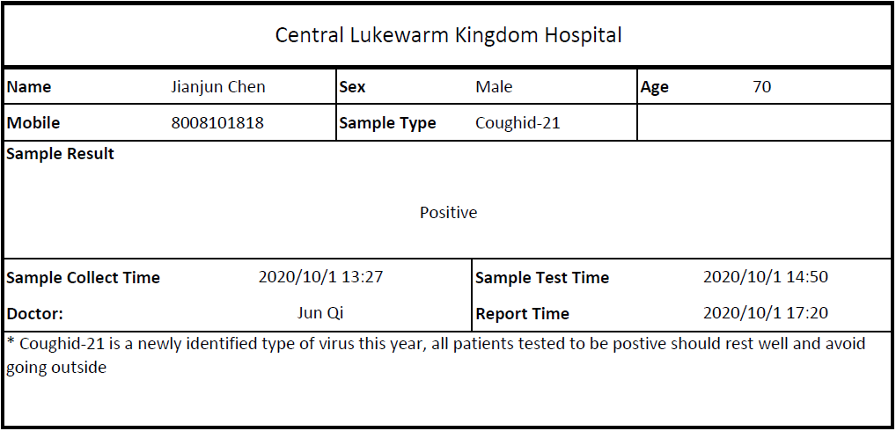

Please write down the detailed normalisation process for the viral test report. Firstly, identify all attributes you can find in the viral test report as well as in the specifications (you need to add your own attributes if your database design has them). Then, at each normalisation stage, list all functional dependencies and normalise them to the higher normal form. 3NF is required for the final tables and must match your ER diagram.

**Stage 1**

**Attributes**:

{citizen_mobile, sample_collect_time, citizen_name, citizen_sex, citizen_age, sample_type, sample_test_time, doctor_name, report_time, description}

Primary key is {citizen_mobile, sample_collect_time }.

No other candidate key.

**FDs (Indicate partial or transitive dependencies)**:

FD1: {citizen_mobile, sample_collect_time} → {citizen_name, citizen_sex, citizen_age, sample_type, sample_test_time, doctor_name, report_time, description}

There is a partial dependencies in FD1.

**Normalised tables and which normal form they are currently in**: Normalised表以及它们当前的标准形式:

R1: {citizen_mobile, sample_collect_time, citizen_name, citizen_sex, citizen_age, sample_type, sample_test_time, doctor_name, report_time, description} **1NF**

**Stage 2**

**Attributes**:

{citizen_mobile, sample_collect_time, citizen_name, citizen_sex, citizen_age, sample_type, sample_test_time, doctor_name, report_time, description}

**FDs (Indicate partial or transitive dependencies)**:

FD2: {citizen_mobile} → { citizen_name, citizen_sex, citizen_age}

FD3: {citizen_mobile, sample_collect_time} → {sample_type, description, sample_result, sample_test_ time, report_time, doctor_name}

FD4: {sample_type} → {description}

There is a transitive dependencies in FD3 and FD4, which is {citizen_mobile, sample_collect_time} → {sample_type} → {description}.

**Normalised tables and which normal form they are currently in**:

R2: {citizen_mobile, citizen_name, citizen_sex, citizen_age} **3NF**

R3: {citizen_mobile, sample_collect_time, sample_type, description, sample_result, sample_test_time, report_time, doctor_name} **2NF**

R4: {sample_type, description}  **3NF**

**Stage 3 [If necessary]**

**Attributes**:

{citizen_mobile, citizen_name, citizen_sex, citizen_age}

{citizen_mobile, sample_collect_time, sample_type, description, sample_result, sample_test_time, report_time, doctor_name}

{sample_type, description}

**FDs (Indicate partial or transitive dependencies)**:

FD5: {citizen_mobile} → { citizen_name, citizen_sex, citizen_age}

FD6: {citizen_mobile, sample_collect_time} → {sample_type, sample_result, sample_test_time, report_ time, doctor_name}

FD7: {sample_type} → {description}

There is a transitive dependencies in FD3 and FD4, which is {citizen_mobile, sample_test_time} → {sample_type} → {description}.

**Normalised tables and which normal form they are currently in**:

R5: {citizen_mobile, citizen_name, citizen_sex, citizen_age} **3NF**

R6: {citizen_mobile, sample_collect_time, sample_type, sample_result, sample_test_time, report_time, doctor_name} **3NF**

R7: {sample_type, description}  **3NF**

# Use Cases

Remember to put all of your SQL statements into the SQL script file, including all SELECT statements and INSERT statements used to insert test data.

## Important Use Cases

This section lists some very important use cases of the PMMS. Your database design is expected to satisfy all of these use cases. Keep in mind that all use cases below should be achieved with a single SELECT statement (unless specified otherwise, sub-queries in a query is not counted as another query). Do not ignore the “explanation” or “proof” parts of this section, as they constitute the majority of your marks. If the SQL keywords/functions you learned cannot achieve these tasks, you are allowed to self-study some other keywords and use them. The example below is very simple and requires a short paragraph of explanation. But your answers should be more detailed.

------ The Beginning of the Example ------

***Use case 0***: Write a query to list all staff members in ‘B007’. In the result, list staff names.

Your SQL statement:

SELECT staff_name FROM staff NATURAL JOIN branch where branch.branch_no = 'B007'

Test data and explanation:

The following staff member information is added to the staff table (some attributes are hidden as they are not related to this task)

|  |  |
| --- | --- |
| Staff_name | Branch_no |
| ‘Jason’ | ‘B007’ |
| ‘Anna’ | ‘B002’ |
| ‘John’ | ‘B007’ |

The corresponding branch numbers ‘B007’ and ‘B002’ have already been added to the branch table.

This test data set contains staff members that are in ‘B007’ and not in ‘B007’. The expected result of the query should only contain staff in ‘B007’. Staff in other branches should be properly filtered out. For this test to work, all existing data in staff and branch need to be deleted first.

The result of the SELECT statement (screenshot):

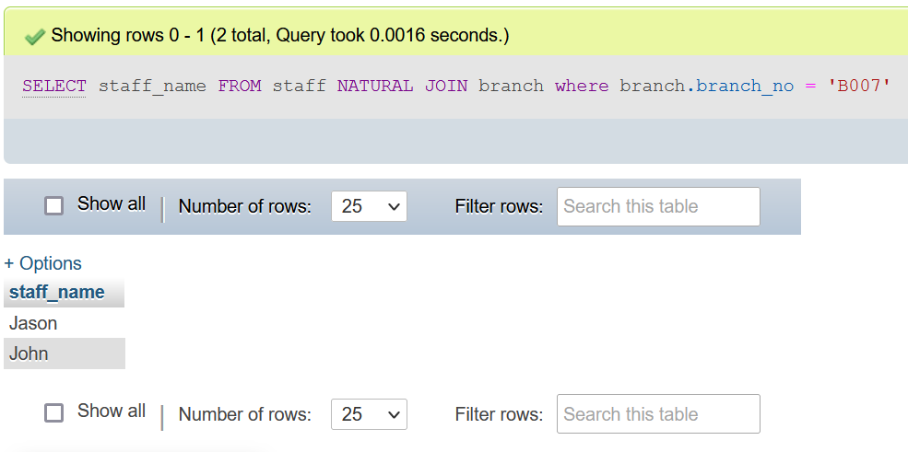

Both the SQL statement and results must appear in the same screenshot!

------ The End of the Example ------

For convenience, I inserted all the data into the table before proceeding with the case, so the table I provide in the following cases may contain some properties that are not relevant to this task. I will explain in each case which properties I actually use and I hope you will understand.

Use case 1: A person can potentially get infected if he was in the same district with someone. The government requires that, if someone is tested to be positive, all people in the same district as him in the past 48 hours (before the positive report is published) need to take viral tests. Assume that a person called Mark was tested to be positive at 19:30 on 09-Oct-2021. Mark’s telephone number is 233636. Please write a query that can get the phone numbers of all citizens who will potentially get infected because of him.

Your SQL statement:

SELECT DISTINCT

citizen.citizen_phone

FROM

citizen

JOIN tracking_information ON citizen.citizen_phone = tracking_information.citizen_phone

JOIN GPS ON tracking_information.district_name = GPS.district_name

WHERE

tracking_information.time_enter >= '2021-10-07 19:30:00' OR tracking_information.time_leave <= '2021-10-09 19:30:00' AND GPS.district_name IN(

SELECT

district_name

FROM

tracking_information

WHERE

citizen_phone = '233636' AND time_enter >= '2021-10-07 19:30:00' OR time_leave <= '2021-10-09 19:30:00'

);

Your test data and why it can prove that the SELECT statement works (Important! Please explain carefully):

The following citizen information is added to the citizen table and I actually use the attribute: citizen_phone.

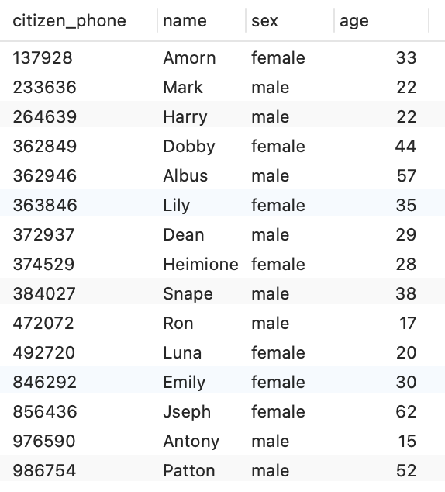

The following tracking information of citizens is added to the tracking_information table and I use all the attributes in it.

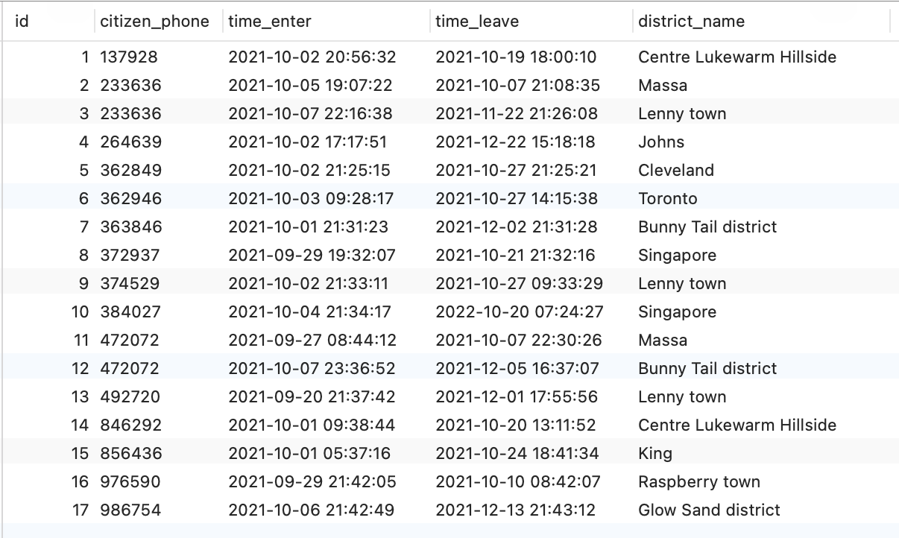

The following gps information is added to the GPS table and I actually use the attributes: gps and district_name.

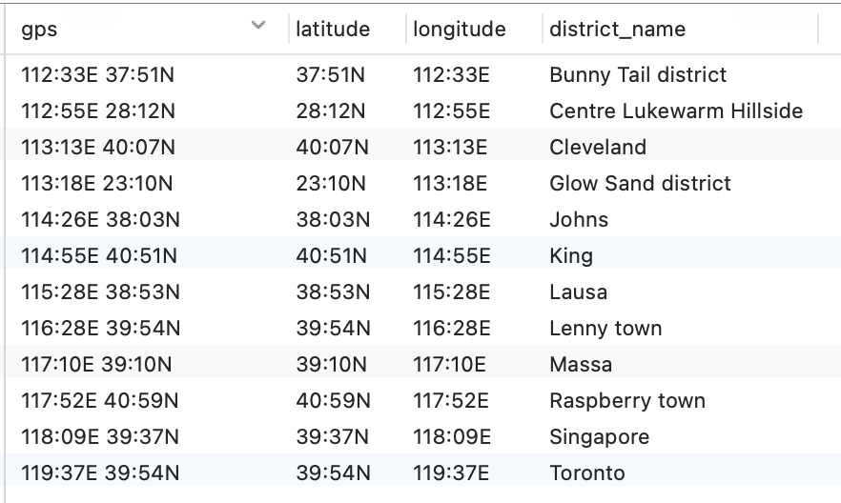

First, use a subquery SELECT

district_name

FROM

tracking_information

WHERE

citizen_phone = '233636' AND time_enter >= '2021-10-07 19:30:00' OR time_leave <= '2021-10-09 19:30:00'

);

to find the districts that Mark visited from 2021-10-7 19:30:00 to 2021-10-9 19:30:00. Then join the citizen table with the tracking_information table and the gps table and provide some constraints, and finally get the result.

The result of the SELECT statement (screenshot):

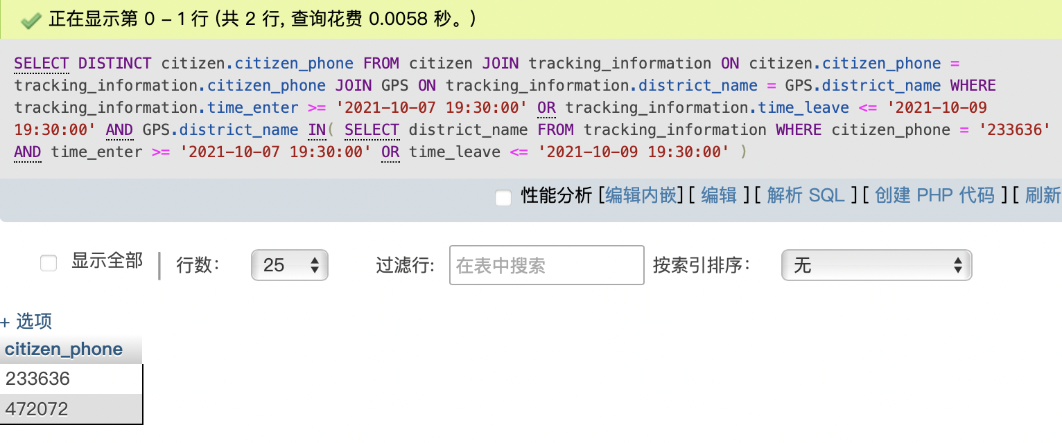

Use case 2: Please first clearly describe the format of GPS locations. The format must be a valid format that is used in real life. Then mimic what happens to your database when a user moves into the range of a base station and then moves out one hour later by listing all SQL statements involved in the process.

The GPS that I set is a combination of latitude and longitude, the format of gps is XXX:YYE ZZ:WWN. For example, ‘116:28E 39:54N.

The GPS format and where did you learn it from (show the website link or the screenshot of the book):

https://blog.csdn.net/dengdun6257/article/details/102284035?ops_request_misc=%257B%2522request%255Fid%2522%253A%2522163950837716780255283001%2522%252C%2522scm%2522%253A%252220140713.130102334.pc%255Fall.%2522%257D&request_id=163950837716780255283001&biz_id=0&utm_medium=distribute.pc_search_result.none-task-blog-2~all~first_rank_ecpm_v1~rank_v31_ecpm-2-102284035.pc_search_result_cache&utm_term=gps格式&spm=1018.2226.3001.4187

The format of gps in the website link is too complex and I simplify it to use only latitude and longitude, which I think is completely adequate.

Your SQL statement(s) for travel record insertion:

INSERT INTO `GPS` (gps, longitude, latitude, district_name)

VALUES

('112:33E 37:51N', '37:51N', '112:33E', 'Bunny Tail district'),

('112:55E 28:12N', '28:12N', '112:55E', 'Centre Lukewarm Hillside'),

('113:13E 40:07N', '40:07N', '113:13E', 'Cleveland '),

('113:18E 23:10N', '23:10N', '113:18E', 'Glow Sand district'),

('114:26E 38:03N', '38:03N', '114:26E', 'Johns'),

('114:55E 40:51N', '40:51N', '114:55E', 'King'),

('115:28E 38:53N', '38:53N', '115:28E', 'Lausa'),

('116:28E 39:54N', '39:54N', '116:28E', 'Lenny town'),

('117:10E 39:10N', '39:10N', '117:10E', 'Massa '),

('117:52E 40:59N', '40:59N', '117:52E', 'Raspberry town'),

('118:09E 39:37N', '39:37N', '118:09E', 'Singapore'),

('119:37E 39:54N', '39:54N', '119:37E', 'Toronto');

The result of the SELECT statements (screenshot):

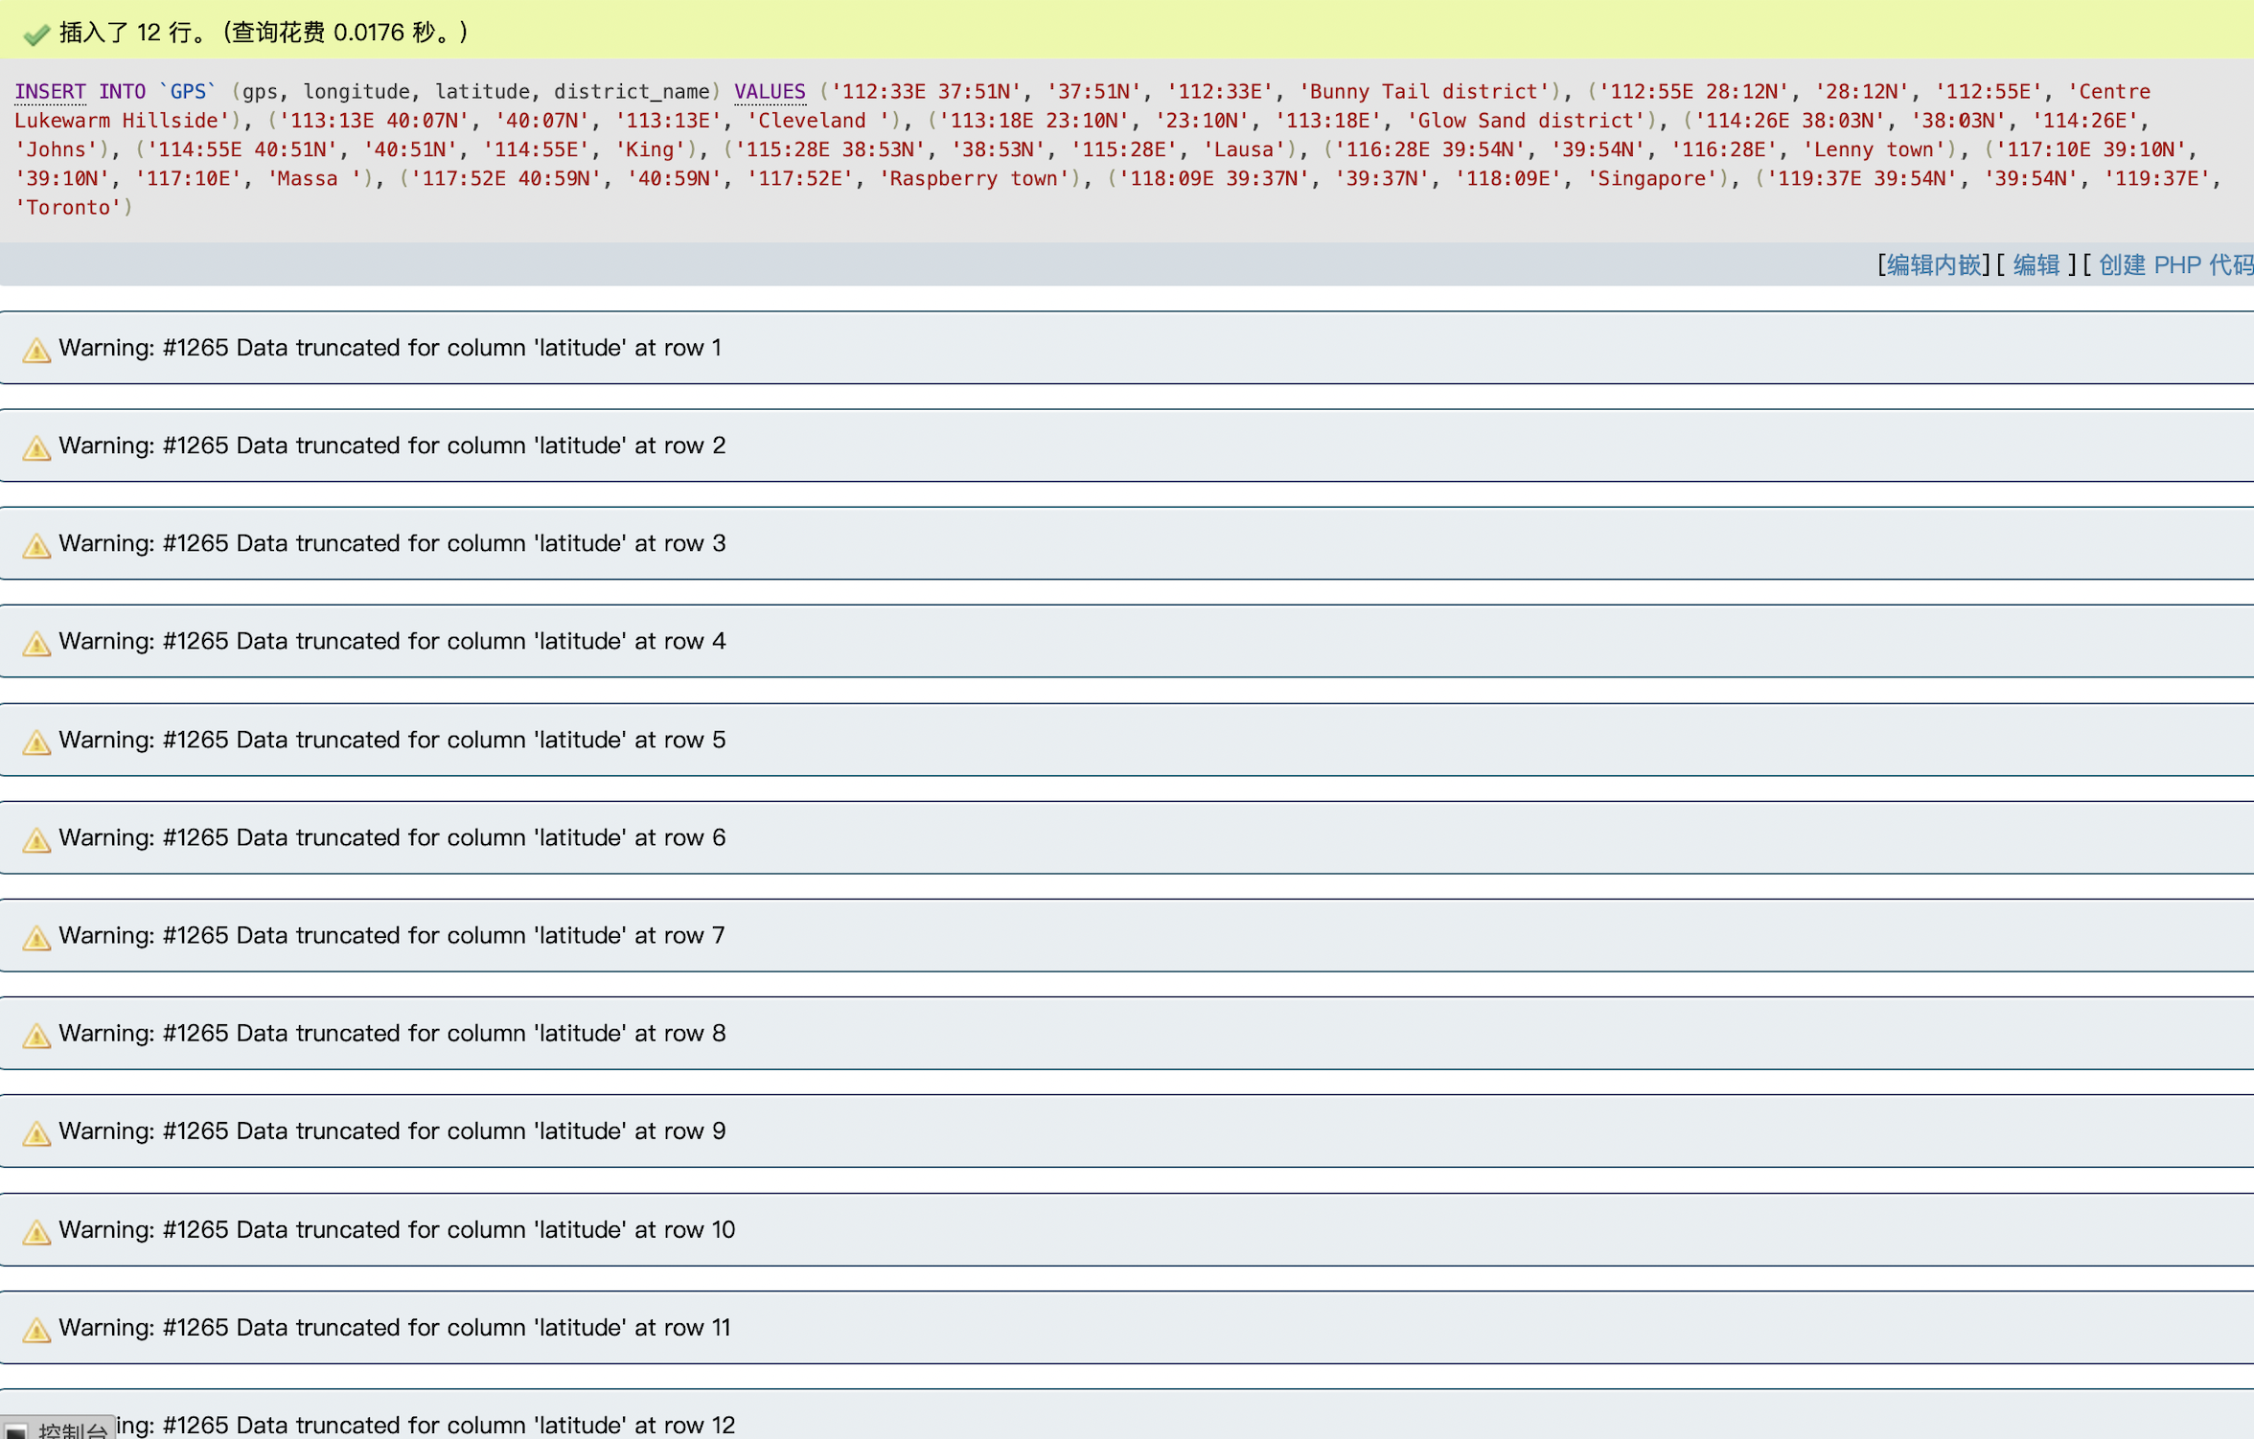

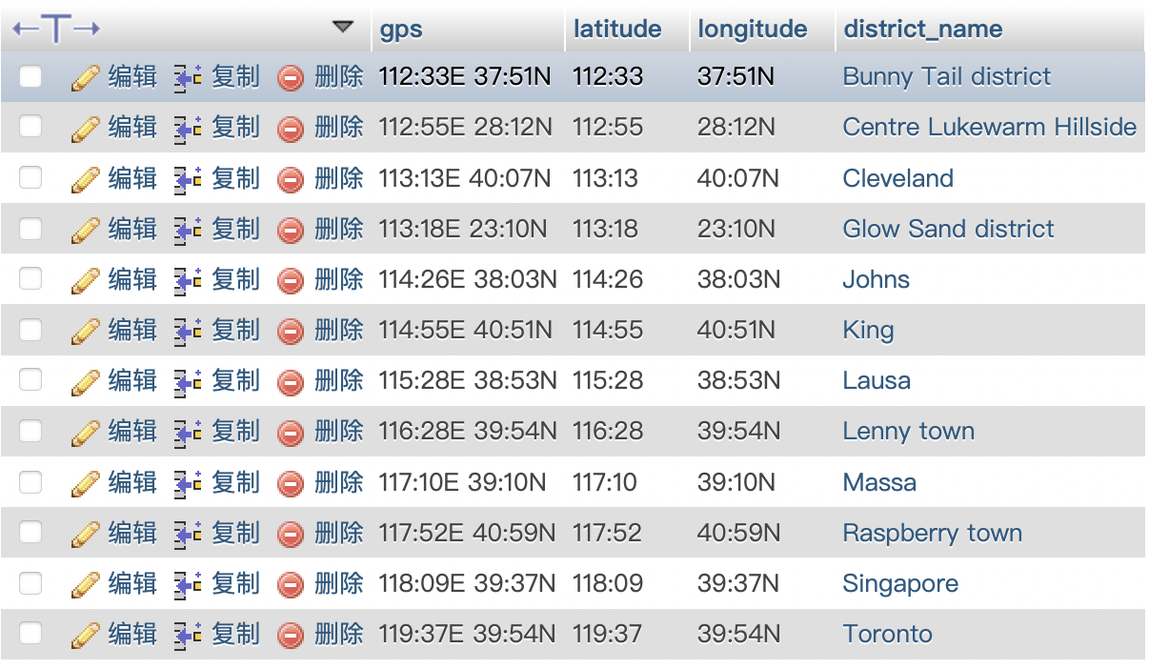

Use case 3: The Lukewarm Kingdom wants to find out the hospitals that can do viral tests efficiently. The report generation time is calculated using (report time - sample test time). Please write a query to find out which hospital has the least average report generation time.

Your SQL statement:

SELECT

a.name,

a.avg_time AS min_time

FROM

(

SELECT

hospital.name,

AVG(

TIMESTAMPDIFF(

HOUR,

report.sample_test_time,

report.report_time

)

) AS avg_time

FROM

report

JOIN hospital ON report.doctor_name = hospital.doctor_name

GROUP BY

hospital.name

) AS a,

(

SELECT

MIN(c.avg_time) AS min_time

FROM

(

SELECT

hospital.name,

AVG(

TIMESTAMPDIFF(

HOUR,

report.sample_test_time,

report.report_time

)

) AS avg_time

FROM

report

JOIN hospital ON report.doctor_name = hospital.doctor_name

GROUP BY

hospital.name

) AS c

) AS b

WHERE

a.avg_time = b.min_time

Your test data and why it can prove that the SELECT statement works (Important! Please explain carefully):

The following report information of citizens is added to the report table and I use the attributes: doctor_name, sample_type and report_time.

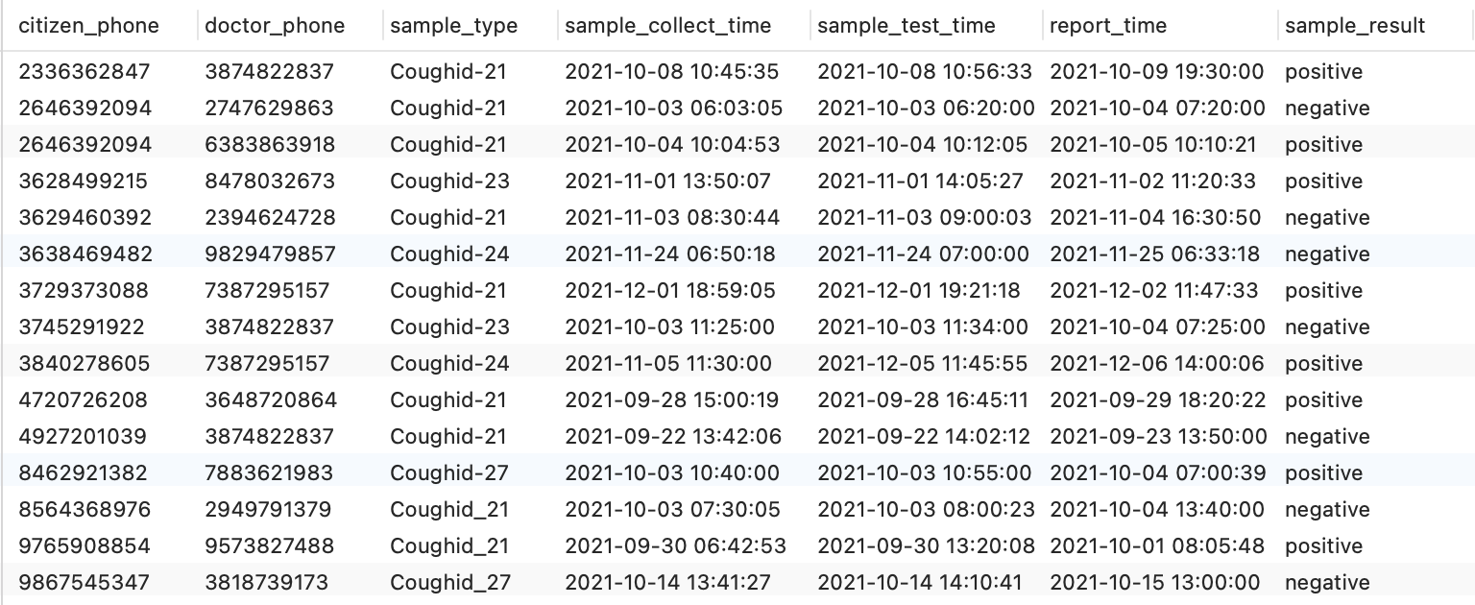

The following hospital information is added to the hosital table and I use the attributes: doctor_name and hospital_name.

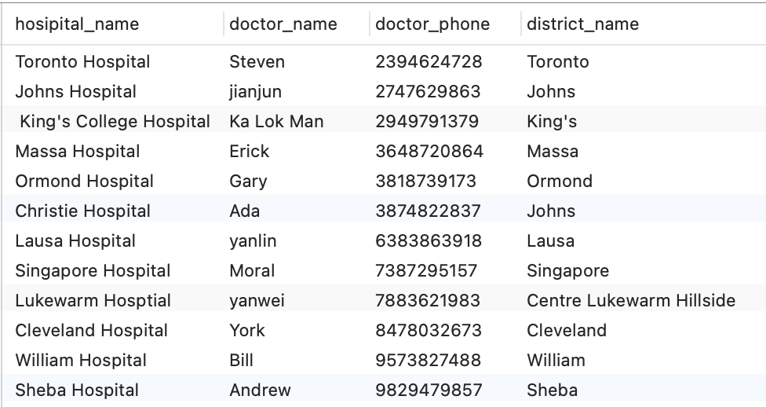

First, use a subquery

SELECT

hospital.name,

AVG(

TIMESTAMPDIFF(

HOUR,

report.sample_test_time,

report.report_time

)

) AS avg_time

FROM

report

JOIN hospital ON report.doctor_name = hospital.doctor_name

GROUP BY

hospital.name

) AS c

to find everyone's report generation time.The use another subquery to caculate the average report generation time of every hospital. Finally, select the hospital corresponding to the minimum value。

The result of the SELECT statement (screenshot):

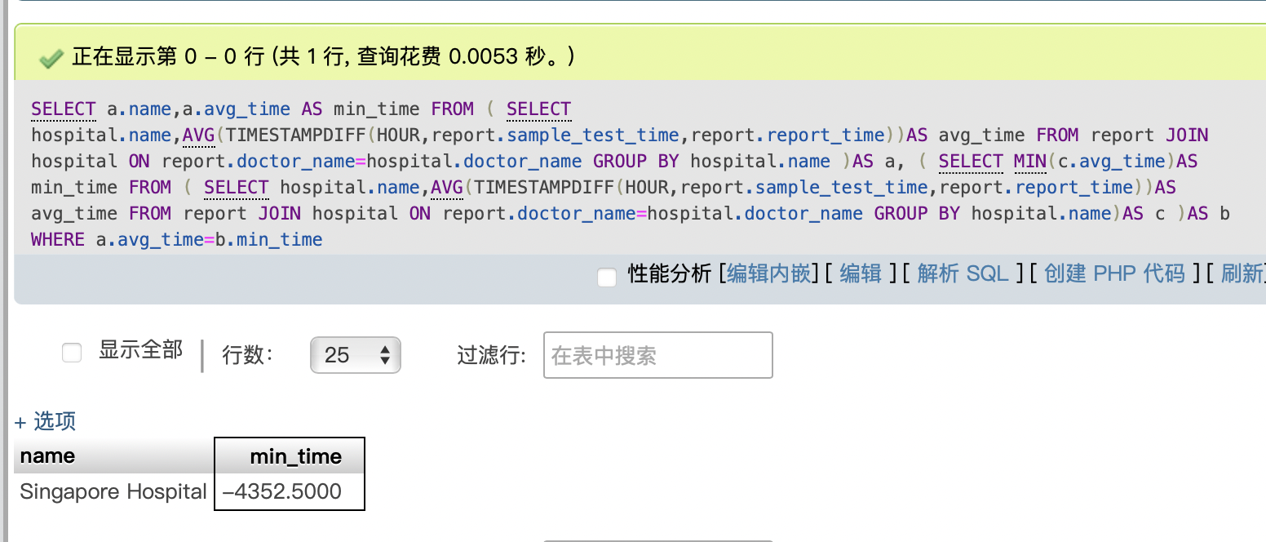

Use case 4: List the phone numbers of all citizens who did two viral tests with the time window from 2021-10-03 00:00 to 2021-10-05 00:00. The two viral tests must have a gap time of at least 24 hours (at least 24 hours apart).

Your SQL statement:

SELECT

citizen_phone

FROM

report

WHERE

citizen_phone IN(

SELECT

citizen_phone

FROM

report

WHERE

citizen_phone IN(

SELECT

citizen_phone

FROM

report

WHERE

sample_test_time > '2021-10-03 00:00' AND sample_test_time < '2021-10-05 00:00'

GROUP BY

citizen_phone

HAVING

COUNT(citizen_phone) = 2

) AND TIMESTAMPDIFF(

HOUR,

(

SELECT

MIN(sample_test_time)

FROM

report r

WHERE

r.citizen_phone = citizen_phone

),

(

SELECT

MAX(sample_test_time)

FROM

report r

WHERE

r.citizen_phone = citizen_phone

)

) > 24

)

GROUP BY

citizen_phone

Your test data and why it can prove that the SELECT statement works (Important! Please explain carefully):

The following report information of citizens is added to the report table and I use the attributes: citizen_phone and sample_test_time.

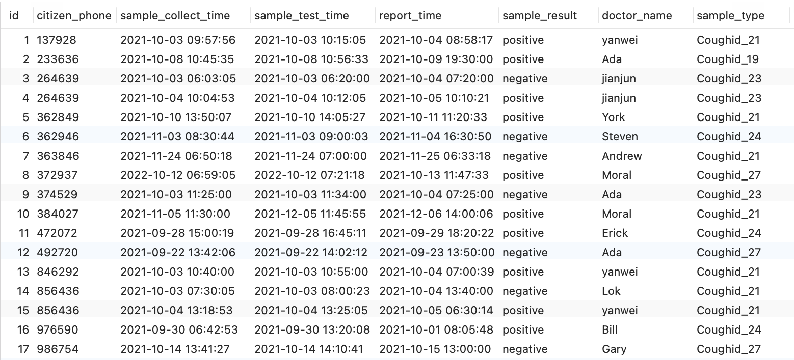

The case has two conditions that two test time between 2021-10-03 00:00 and 2021-10-05 00:00 and the gap time of at least 24 hours, so the two conditions are juxtaposed.Then it can use AND to connect them. Therefore, I use HAVING COUNT for the first condition and use TIMESTAMPDIFF for the second condition.

The result of the SELECT statement (screenshot):

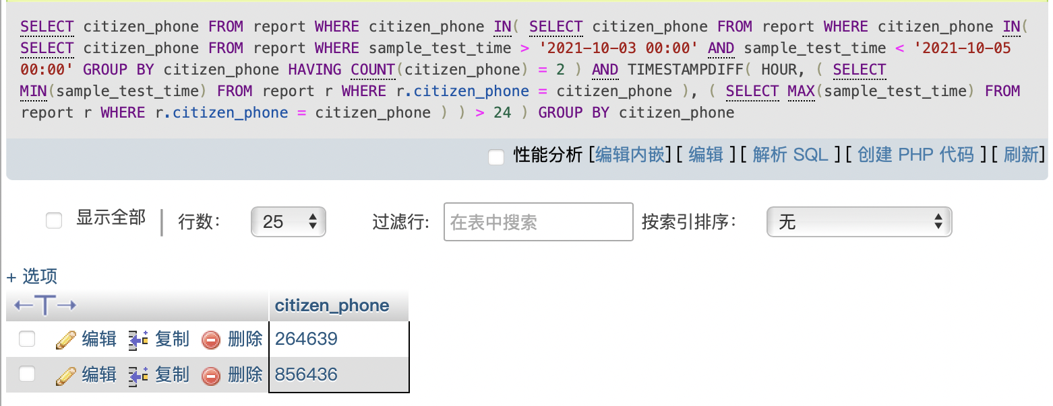

Use case 5: List the high-risk, mid-risk and low-risk districts using one query. High-risk districts should be listed first, followed by mid-risk districts and then low-risk districts. Example:

|  |  |
| --- | --- |
| **district_name** | **risk_level** |
| Centre Lukewarm Hillside | high |
| Lenny town | high |
| Glow Sand district | mid |
| Raspberry town | low |
| Bunny Tail district | low |

Your SQL statement:

SELECT

district.district_name,

'high' risk_level

FROM

report

JOIN tracking_information ON report.citizen_phone = tracking_information.citizen_phone

JOIN district ON tracking_information.district_name = district.district_name

WHERE

report.sample_result = 'positive' AND TIMESTAMPDIFF(

HOUR,

tracking_information.time_enter,

tracking_information.time_leave

) > 24

GROUP BY

district.district_name

UNION

SELECT

district.district_name,

'mid' risk_level

FROM

report

JOIN tracking_information ON report.citizen_phone = tracking_information.citizen_phone

JOIN district ON tracking_information.district_name = district.district_name

WHERE

report.sample_result = 'positive' AND TIMESTAMPDIFF(

HOUR,

(

SELECT

MIN(sample_test_time)

FROM

report r

WHERE

sample_result = 'positive'

),

(

SELECT

MAX(sample_test_time)

FROM

report r

WHERE

sample_result = 'positive'

)

) <= 7

GROUP BY

district.district_name

UNION

SELECT

district.district_name,

'low' risk_level

FROM

report

JOIN tracking_information ON report.citizen_phone = tracking_information.citizen_phone

JOIN district ON tracking_information.district_name = district.district_name

WHERE

report.sample_result != 'positive' AND TIMESTAMPDIFF(

HOUR,

(

SELECT

MIN(sample_test_time)

FROM

report r

WHERE

sample_result != 'positive'

),

(

SELECT

MAX(sample_test_time)

FROM

report r

WHERE

sample_result != 'positive'

)

) <= 7

GROUP BY

district.district_name

Your test data and why it can prove that the SELECT statement works (Important! Please explain carefully):

The following district information is added to the district table and I actually use the attributes: district_name and risk_level. 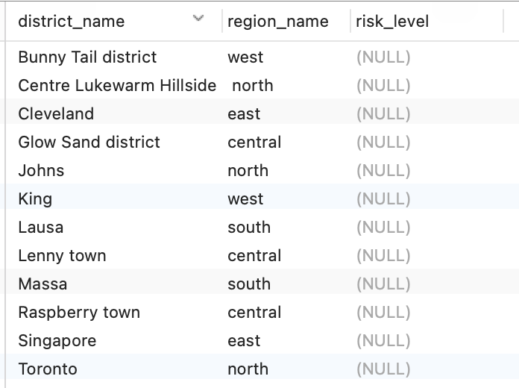

The following report information of citizens is added to the report table and I use the attributes: citizen_phone, sample_test_time and sample_result.

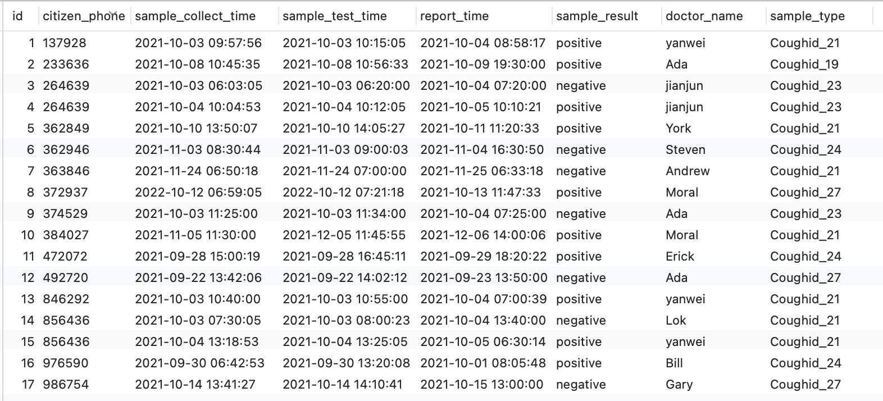

The following tracking information of citizens is added to the tracking_information table and I use the attributes: citizen_phone, district_name.

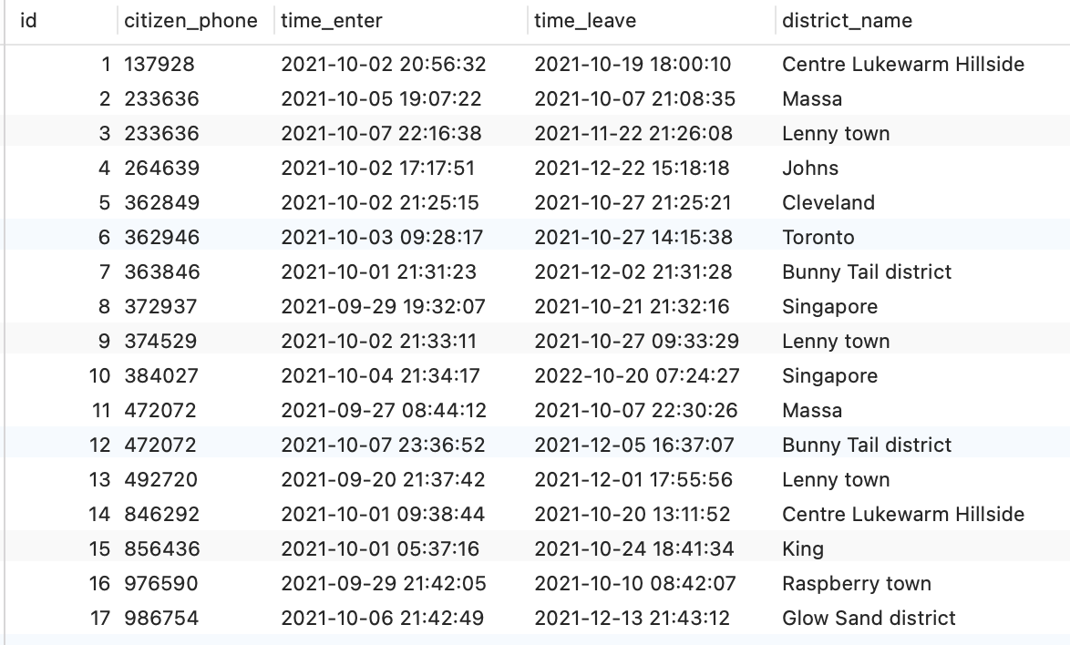

Obviously， this query is divided into high risk, medium risk and low risk, and I use UNION to connect them.Every subquery use TIMESTAMPDIFF to judge.

Then join the report table with the tracking_information table and the district table and provide some constraints, and finally get the result.

The result of the SELECT statement (screenshot):

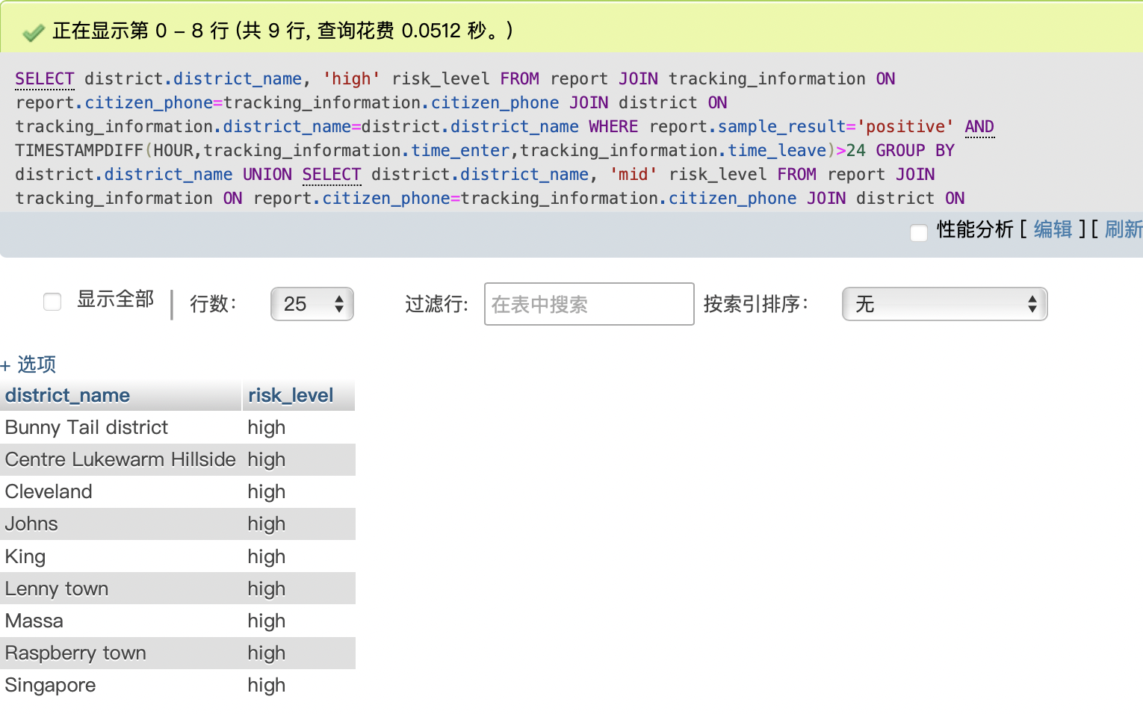

Use case 6: List all positive cases found in the district called “Centre Lukewarm Hillside” on 2021-10-04. The result should include the names and phone numbers of people tested to be positive.

Your SQL statement:

SELECT

citizen.name,

citizen.citizen_phone

FROM

citizen

JOIN report ON citizen.citizen_phone = report.citizen_phone

JOIN tracking_information ON report.citizen_phone = tracking_information.citizen_phone

JOIN district ON tracking_information.district_name = district.district_name

WHERE

report.sample_result = 'positive' AND report.report_time LIKE '2021-10-04%' AND district.district_name = 'Centre Lukewarm Hillside'

Your test data and why it can prove that the SELECT statement works (Important! Please explain carefully):

The following citizen information is added to the citizen table and I actually use the attribute: citizen_phone and name.

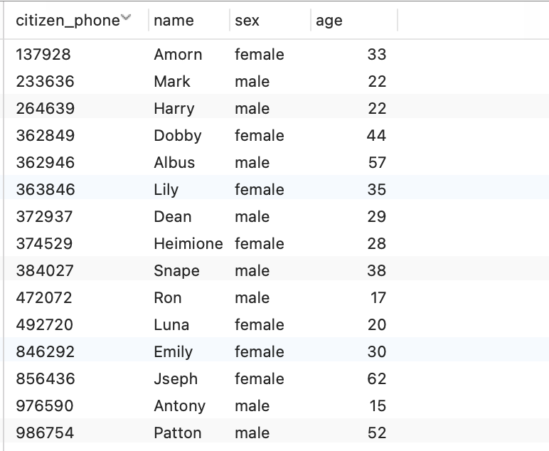

The following report information of citizens is added to the report table and I use the attributes: citizen_phone, report_time and sample_result.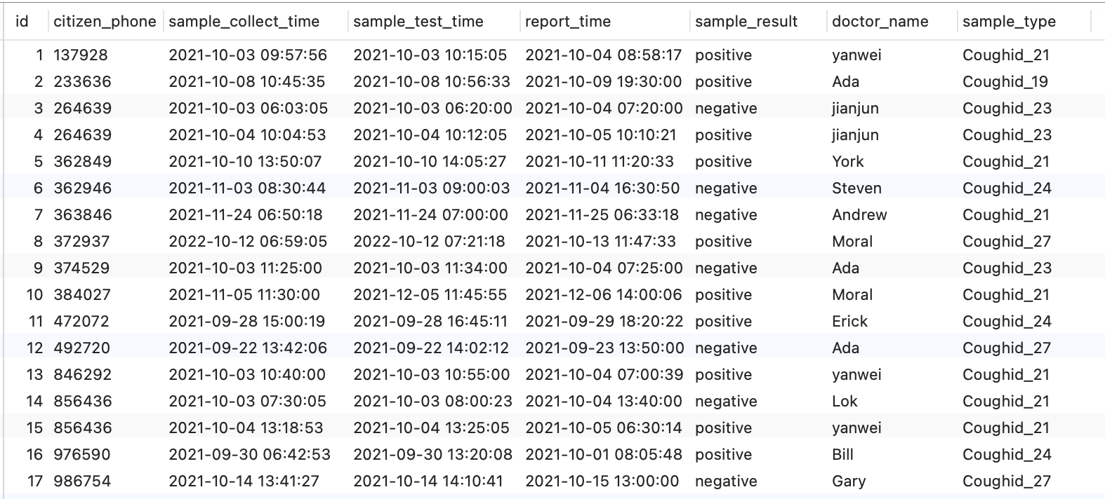

The following district information is added to the district table and I actually use the attribute: district_name.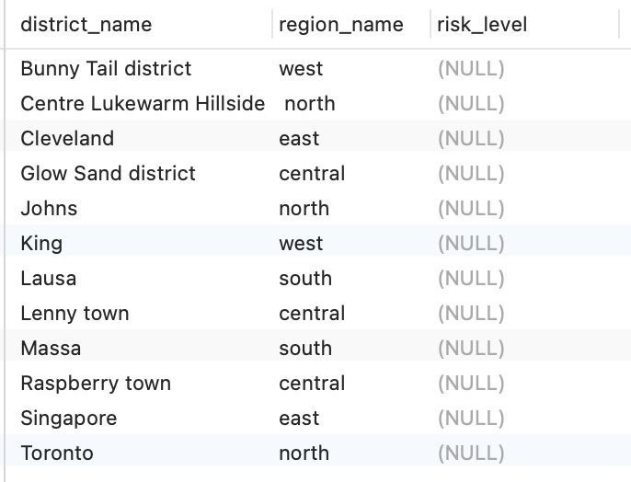

The following tracking information of citizens is added to the tracking_information table and I use the attributes: citizen_phone and district_name.

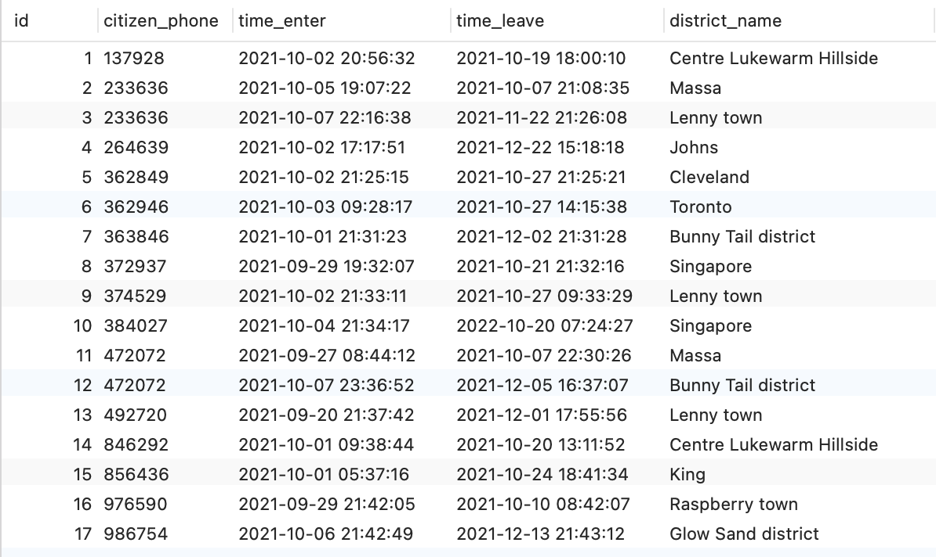

Use JOIN to connect citizen with tables that contains report, tracking  
_information and district, and there are some constraints. The conditions in WHERE are juxtaposed and they should be connected with AND.

The result of the SELECT statement (screenshot):

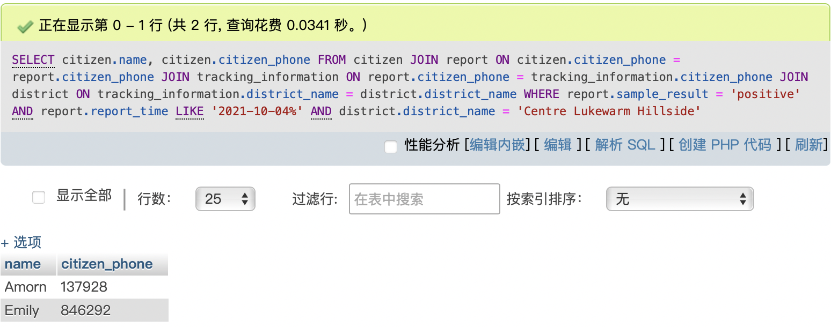

Use case 7: Calculate the increase in new positive cases in the district called “Centre Lukewarm Hillside” on 2021-10-05 compared to 2021-10-04. The result should show a single number indicating the increment. If there are fewer new positive cases than yesterday, this number should be negative.

Your SQL statement:

SELECT

(

(

SELECT

COUNT(*) AS case_num

FROM

report

JOIN tracking_information ON report.citizen_phone = tracking_information.citizen_phone

JOIN district ON tracking_information.district_name = district.district_name

WHERE

report.sample_result = 'positive' AND report.report_time LIKE '2021-10-05%' AND district.district_name = 'Centre Lukewarm Hillside'

) -(

SELECT

COUNT(*) AS case_num

FROM

report

JOIN tracking_information ON report.citizen_phone = tracking_information.citizen_phone

JOIN district ON tracking_information.district_name = district.district_name

WHERE

report.sample_result = 'positive' AND report.report_time LIKE '2021-10-04%' AND district.district_name = 'Centre Lukewarm Hillside'

)

) AS add_num

Your test data and why it can prove that the SELECT statement works (Important! Please explain carefully):

The following tracking information of citizens is added to the tracking_information table and I use the attributes: citizen_phone and district_name.



The following report information of citizens is added to the report table and I use the attributes: citizen_phone, report_time and sample_result.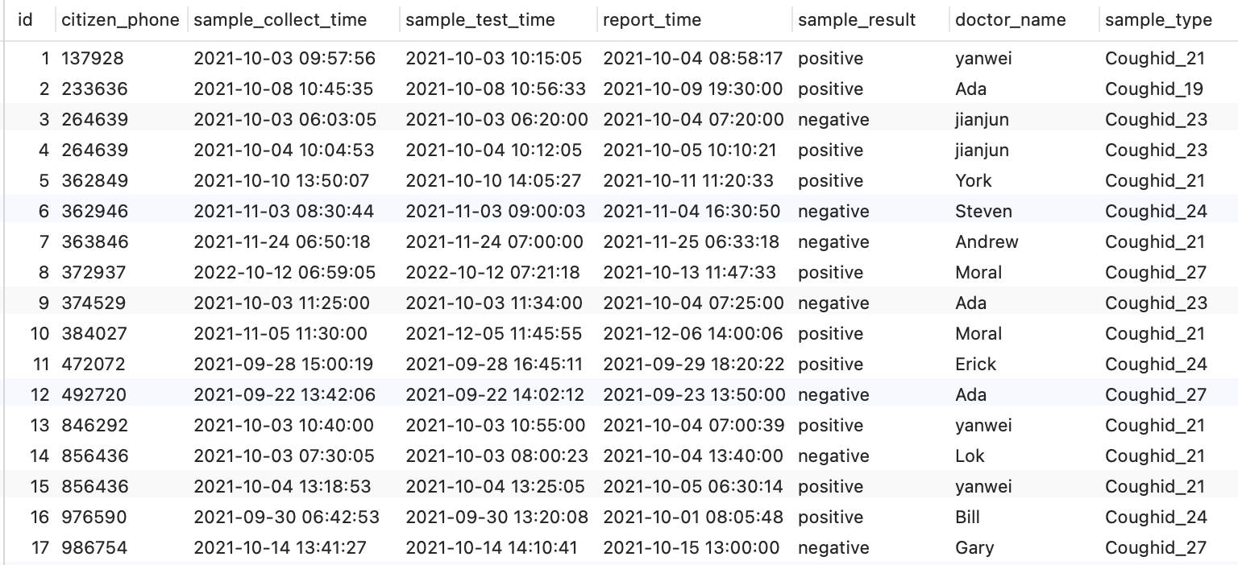

The following district information of districts is added to the district table and I use the attribute: district_name.



The case is to use positive cases on 2021-10-5 minus positive cases on 2021-10-4 in "Centre Lukewarm Hillside ".I select the number of positive cases on each of the two days and then subtracted them.

The result of the SELECT statement (screenshots):

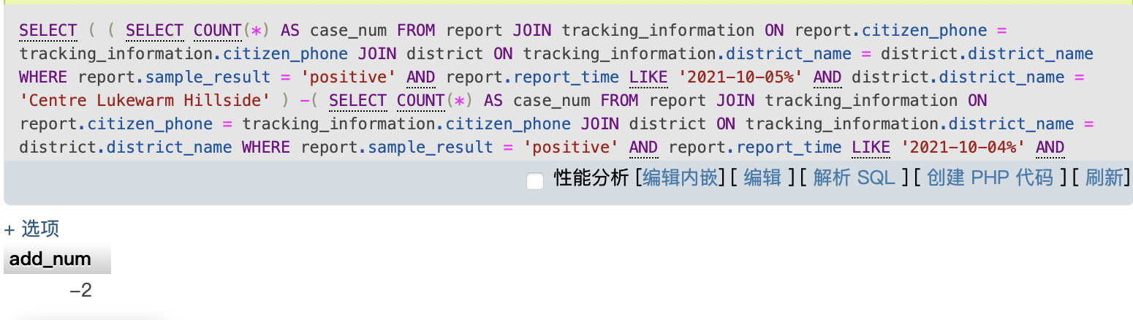

Use case 8: Assume that the spread rate of a virus is calculated by dividing the total number of people that were in the same district as the positive case with 48 hours (calculated in use case 1) by the total number of people among them that later confirmed to be infected in 14 days. Again, assume that a person called Mark (telephone number is 233636) was tested to be positive at 19:30 on 09-Oct-2021 and he is the only person in the country that has coughid-19. Please write a query that calculates the spread rate of the virus.

Your SQL statement:

Your test data and why it can prove that the SELECT statement works (Important! Please explain carefully):

The result of the SELECT statement (screenshots):

## Extended Use Cases

Apart from the use cases proposed in the previous section, your database could also support more scenarios. Please follow the same format in the previous section and write down your own 10 use cases. You are allowed to use keywords learned outside of the lectures. Practical use cases displaying good innovations will receive higher marks.

Use case 1: List all phone number of citizen whose age is between 20 and 30(not include both ends)

Your SQL statement:

SELECT

citizen_phone

FROM

citizen

WHERE

citizen.age BETWEEN 20 AND 30;

Your test data and why it can prove that the SELECT statement works (Important! Please explain carefully):

The following citizen information is added to the citizen table and I actually use the attributes: citizen_phone and age.

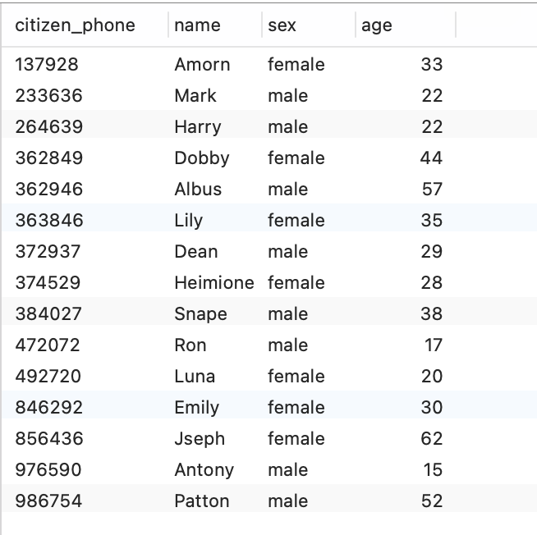

It’s a easy query which use WHERE.

The result of the SELECT statement (screenshot):

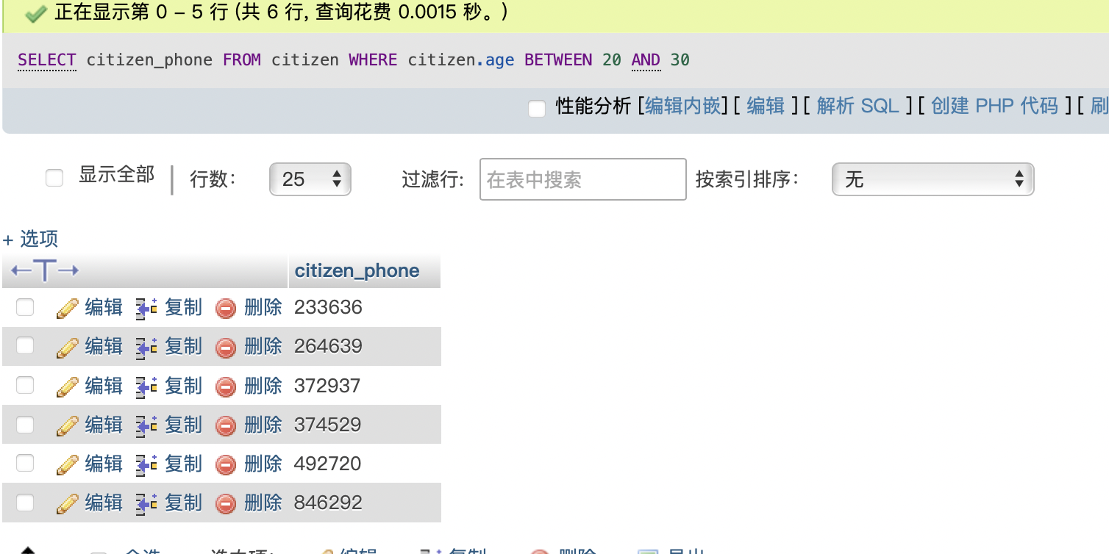

Use case 2: Sort the citizen table by age from lowest to highest

Your SQL statement:

SELECT

*

FROM

`citizen`

ORDER BY

age ASC;

Your test data and why it can prove that the SELECT statement works (Important! Please explain carefully):

The following citizen information is added to the citizen table and I actually use the attribute: age.



It’s a query which use ORDER BY.

The result of the SELECT statement (screenshot):

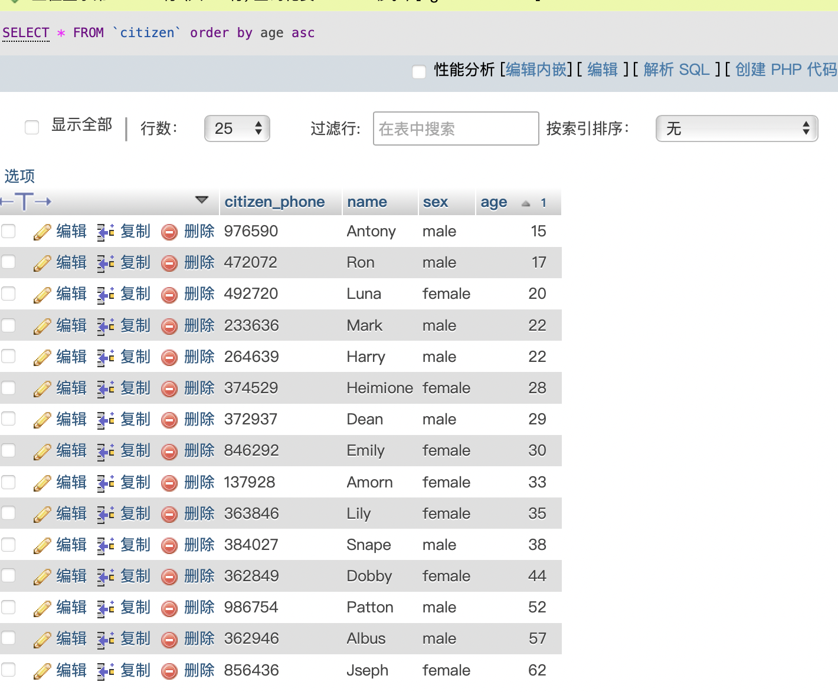

Use case 3: List the phone numbers of all citizens who did two viral tests between 2021-10-01 00:00 and 2021-11-20 00:00.

Your SQL statement:

SELECT DISTINCT

citizen_phone

FROM

report

WHERE

sample_test_time BETWEEN '2021-10-01 00:00' AND '2021-11-20 00:00'

GROUP BY

citizen_phone

HAVING

COUNT(*) = 2;

Your test data and why it can prove that the SELECT statement works (Important! Please explain carefully):

The following report information of citizens is added to the report table and I use the attributes: citizen_phone and sample_test_time. 

Select the citizens who did test between 2021-10-01 00:00 and 2021-11-20 00:00 and the count of test iss 2.

The result of the SELECT statement (screenshot):

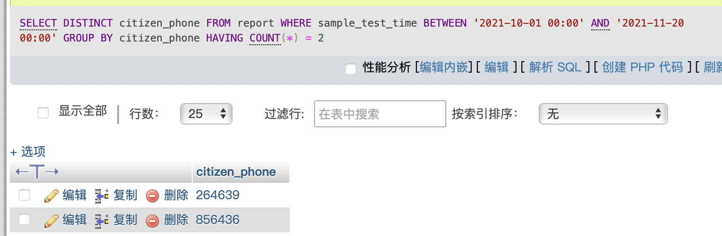

Use case 4: List the phone numbers of all citizens whose phone number is begin with 3.

Your SQL statement:

SELECT

citizen_phone

FROM

citizen

WHERE

LEFT(citizen_phone, 1) = 3;

Your test data and why it can prove that the SELECT statement works (Important! Please explain carefully):

The citizen information of citizens is added to the citizen table and I use the attribute: citizen_phone.



Use LEFT(citizen_phone, 1) to query the characters in a string.

The result of the SELECT statement (screenshot):

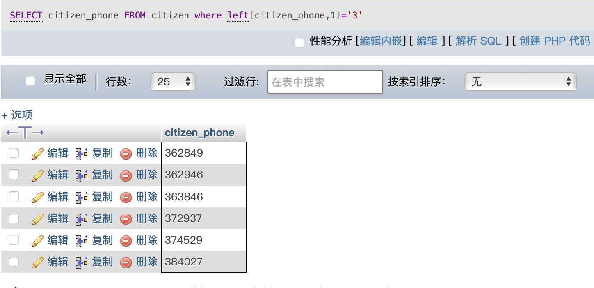

Use case 5: List the phone numbers of all citizens who stayed in Johns on 2021-10-06.

Your SQL statement:

SELECT

citizen_phone

FROM

tracking_information

WHERE

time_enter <= '2021-10-06 00:00' AND time_leave >= '2021-10-7 00:00' AND district_name = 'Johns';

Your test data and why it can prove that the SELECT statement works (Important! Please explain carefully):

The following tracking information of citizens is added to the tracking_information table and I use the attributes: citizen_phone. time_enter, time_leave and district_name›.

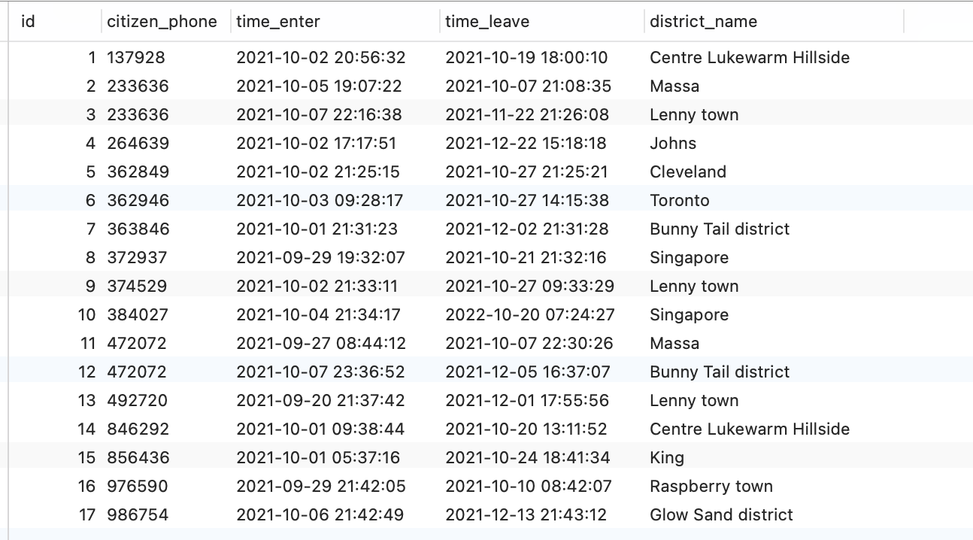

The result of the SELECT statement (screenshot):

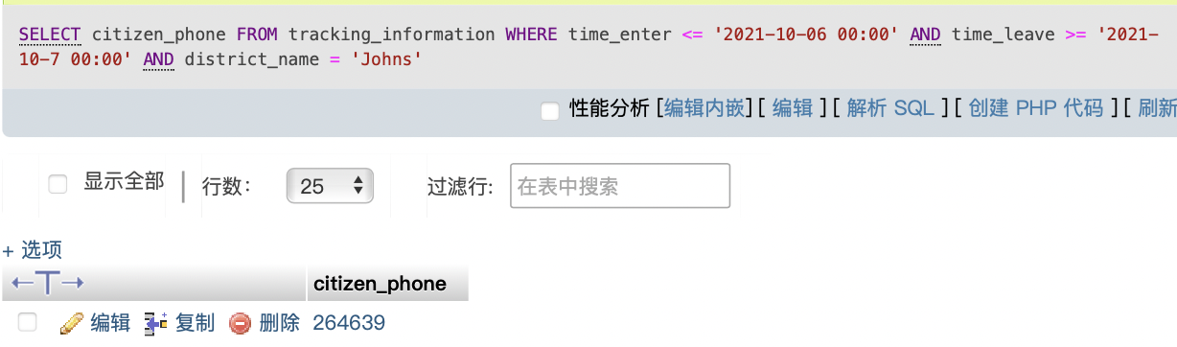

Use case 6: List the phone numbers of all citizens who got Coughid_21.

Your SQL statement:

SELECT

citizen_phone

FROM

report

WHERE

sample_result = 'positive' AND sample_type = 'Coughid_21';

Your test data and why it can prove that the SELECT statement works (Important! Please explain carefully):

The following report information of citizens is added to the report table and I use the attributes: citizen_phone, sample_result and sample_type. 

It’s a easy query using WHERE and AND.

The result of the SELECT statement (screenshot):

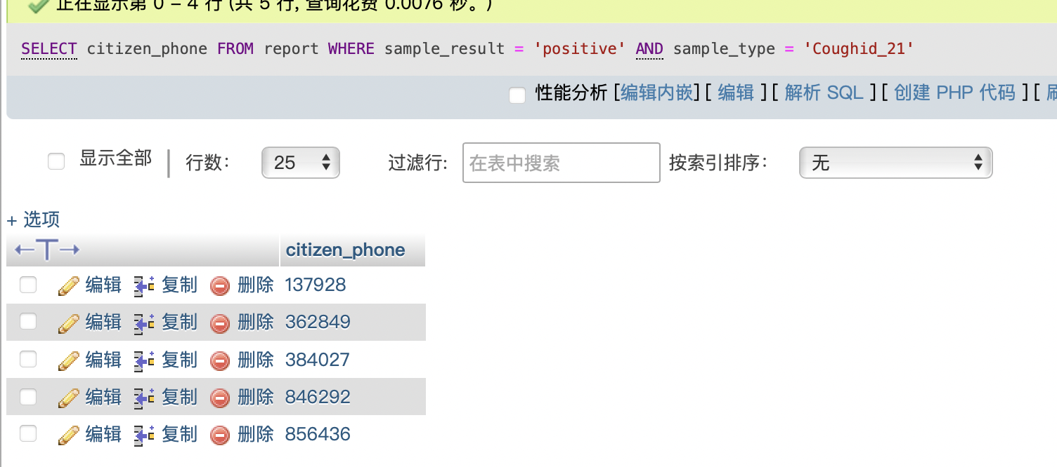

Use case 7: List the longest name of districts.

Your SQL statement:

SELECT

`district_name`,

LENGTH(`district_name`)

FROM

district

WHERE

LENGTH(`district_name`) =(

SELECT

MAX(LENGTH(`district_name`))

FROM

district

)

Your test data and why it can prove that the SELECT statement works (Important! Please explain carefully):

The following district information of districts is added to the district table and I use the attribute: district_name.



Use the method of MAX(LENGTH(``))

The result of the SELECT statement (screenshot):

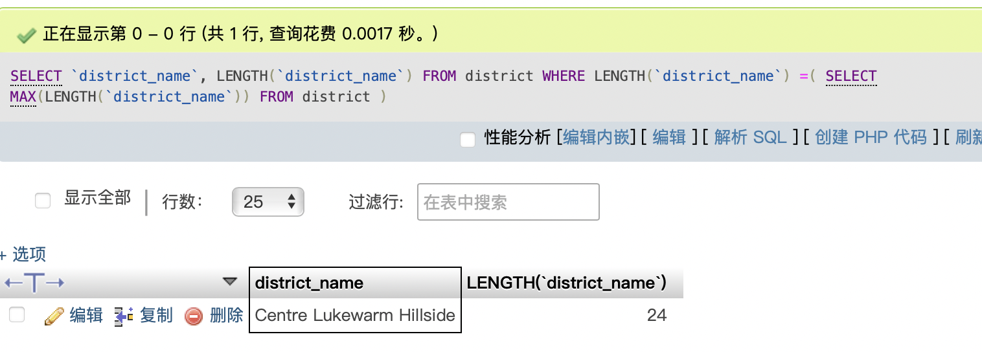

Use case 8: List the report of citizens whose doctor is jianjun.

Your SQL statement:

SELECT

*

FROM

report

WHERE

doctor_name = 'jianjun';

Your test data and why it can prove that the SELECT statement works (Important! Please explain carefully):

The following report information of citizens is added to the report table and I use the attributes: id, citizen_phone, smple_collect_time, report_time, sample_result, doctor_name and sample_type.



Use WHERE.

The result of the SELECT statement (screenshot):

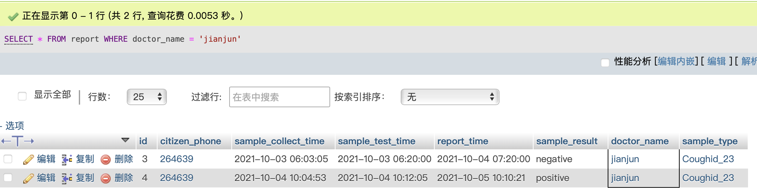

Use case 9: Find the citizen phone number with more than 1 virus detection time and its corresponding record times t.

Your SQL statement:

SELECT

citizen_phone,

COUNT(citizen_phone) AS t

FROM

report

GROUP BY

citizen_phone

HAVING

COUNT(*) > 1

Your test data and why it can prove that the SELECT statement works (Important! Please explain carefully):

The following report information of citizens is added to the report table and I use the attributes: citizen_phone.

Use GROUP BY and HAVING COUNT().

The result of the SELECT statement (screenshot):

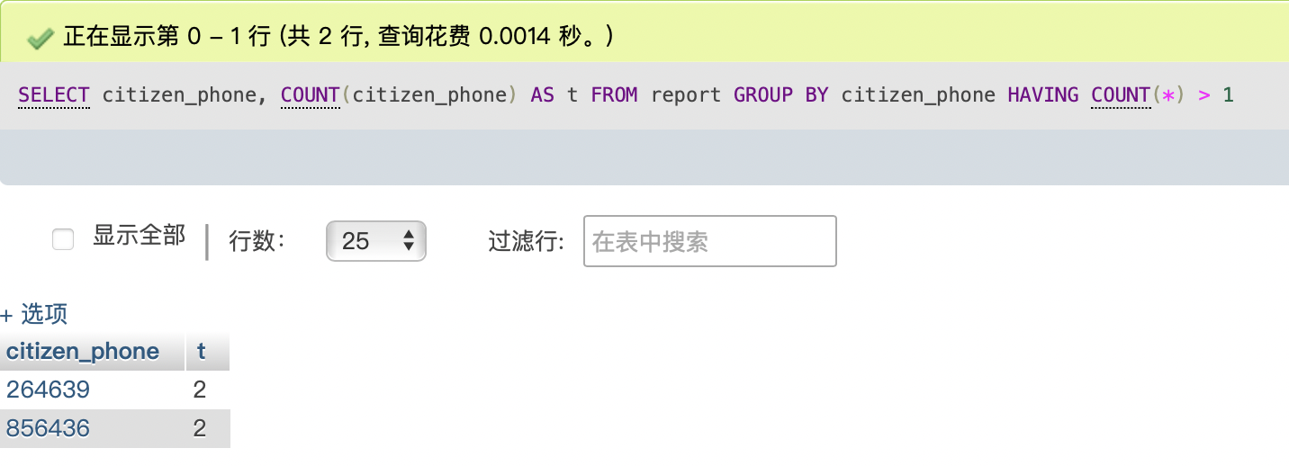

Use case 10: List the report of citizen from sample_collect_time to sample_test_time of more than 20 minutes.

Your SQL statement:

SELECT

*

FROM

report

WHERE

TIMESTAMPDIFF(

MINUTE,

sample_collect_time,

sample_test_time

) > 20;

Your test data and why it can prove that the SELECT statement works (Important! Please explain carefully):

The following report information of citizens is added to the report table and I use the attributes: id, citizen_phone, smple_collect_time, report_time, sample_result, doctor_name and sample_type.



The case is to minus sample_test_time with sample_collect_time, so I use the TIMESTAMPDIFF.

The result of the SELECT statement (screenshot):

